The Marriage Ceremony
PRELUDE OF CLASSICAL SELECTIONS

THE SEATING OF THE MOTHERS
Entreat Me Not To Leave Thee ~ Gounod

The Processional
THE CHIMING OF THE HOUR

THE BRIDAL PARTY
Trumpet Tune and Air ~ Purcell

THE ENTRANCE OF THE BRIDE
Highland Cathedral ~ Roever/Korb

The Celebration and Blessing
of a Marriage

THE INVOCATION AND GREETING

THE PRESENTATION OF THE BRIDE

HOMILY

THE EXCHANGE OF VOWS

THE EXCHANGE OF RINGS

THE BLESSING OF THE MARRIAGE

LIGHTING OF THE UNITY CANDLE
The Lord’s Prayer ~ Mallotte

The Presentation of the Couple

THE RECESSIONAL
Allegro Maestoso ~ Handel
The Wedding Party

PARENTS OF THE BRIDE
Name of parents

PARENTS OF THE GROOM
Name of parents

MAID OF HONOR
Name

BRIDESMAIDS
Names
Names
Names
Names

BEST MAN
Name

GROOMSMEN
Names
Names
Names
Names

VOCALIST
Name

OFFICIANT
Rev. R. Marshall Blalock

ORGANIST
Dr. Beverly C. Bradley

In Honor and Memory
The floral arrangement in the baptistry is given in honor and in memory of those special people who cannot be with us today but have played such an important role in molding the lives of Lauren and Hampton.

In Honor of
Names if any

In Memory of
Names if any

The Reception
NAME OF RECEPTION SITE

EX. Of DirectionsExit the front entrance of the church and go north down Church Street to Broad Street. Turn right onto Broad Street. Turn left onto East Bay Street. Turn right onto Cordes Street. Turn left onto Prioleau Street. The Harbour Club is located at 35 Prioleau Street. You may leave your car parked at the church. There is also a parking garage on Prioleau Street one block away on your right.

In Appreciation
We know many of you have traveled great distances to be here, and we want to thank each of you for sharing in our special day. We are so grateful for our family and friends and the support we have been shown throughout the years. We are blessed to have all of you in our lives and are honored to share this joyful occasion with you.

First Baptist Church

61 Church Street ~ Charleston, South Carolina Founded in 1682, the oldest Baptist Church in the south. The present sanctuary, designed by Robert Mills, the first American-born architect, was completed in the 1820s. The structure has received national acclaim for its
classic design and beauty.

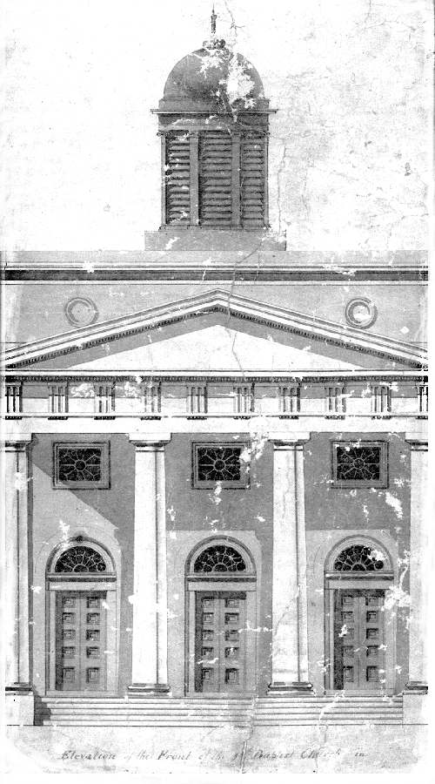

The Celebration and Marriage

OF

Brides Name

AND

Grooms Name

SATURDAY, THE DATE OF MONTH

TWO THOUSAND AND NINETEEN

TIME IN THE EVENING

THE FIRST BAPTIST CHURCH of

CHARLESTON, SOUTH CAROLINA

